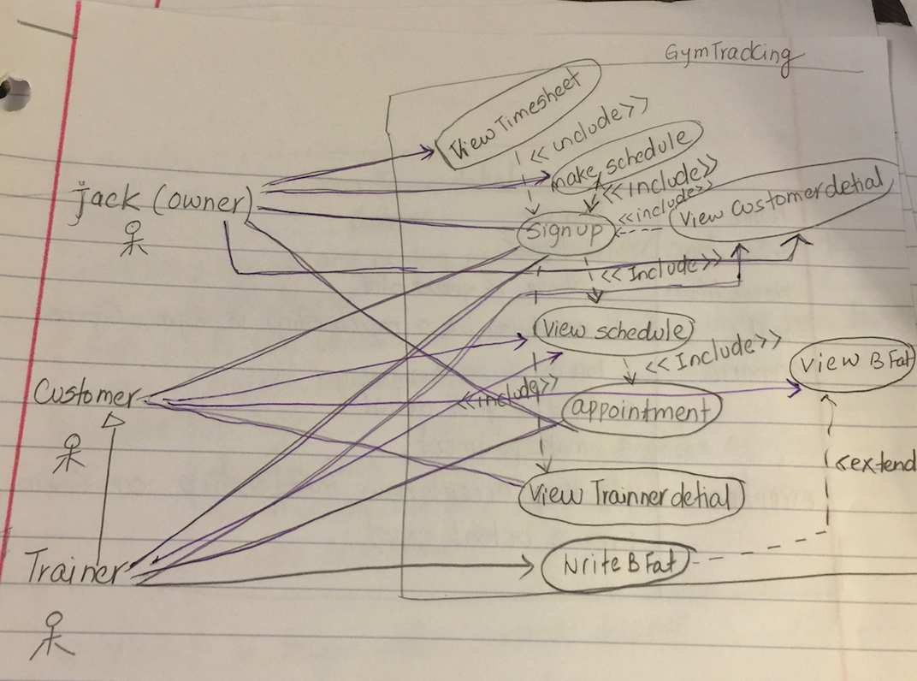

|  |  |
| --- | --- |
| Name | Make appointment |
| Actor | customer |
| precondition | Customer has to sign in |
| Goal | Customer want to make an appointment with available trainer |
| Scenario | 1.login  2.find a available trainer and make an appointment  3. Select the trainer and data and time and book the appointment. |
| exception | Customer cannot make appointment with trainer unless he/she has a membership |

|  |  |
| --- | --- |
| Name | Sign in |
| Actor | customer |
| precondition | Have a valid ID and above 16 years |
| Goal | Want to access the gym or obtain a membership |
| Scenario | 1. Go to website and filled up the form  2. Chose visitor or membership |
| exception | If gym allows visitors or offer any membership |

|  |  |
| --- | --- |
| Name | View schedule |
| Actor | Customer |
| precondition | Signed in and membership holder |
| Goal | View tranier’s schedule |
| Scenario | 1. View trainer's schedule and booked it |
| exception | There is trainer available with your time |

|  |  |
| --- | --- |
| Name | View report |
| Actor | customer |
| precondition | Be a membership holder and report is available online |
| Goal | View customer's body report and plan his/ her workout and diet to reach his goal |
| Scenario | Get your body fat details with your trainer |
| exception | Not membership or never be with your trainer to check your body fat |